This page: Table of Contents and Team Member Listing

|  |  |  |
| --- | --- | --- |
| Table of Contents  [1 Game Overview](https://n-xovwktmtjsnaxyc2mwes2xu7pohqedmdm6zjw5q-2lu-script.googleusercontent.com/userCodeAppPanel)  [2 High Concept](https://n-xovwktmtjsnaxyc2mwes2xu7pohqedmdm6zjw5q-2lu-script.googleusercontent.com/userCodeAppPanel)  [3 Unique Selling Points](https://n-xovwktmtjsnaxyc2mwes2xu7pohqedmdm6zjw5q-2lu-script.googleusercontent.com/userCodeAppPanel)  [4 Platform Minimum Requirements](https://n-xovwktmtjsnaxyc2mwes2xu7pohqedmdm6zjw5q-2lu-script.googleusercontent.com/userCodeAppPanel)  [5 Competitors / Similar Titles](https://n-xovwktmtjsnaxyc2mwes2xu7pohqedmdm6zjw5q-2lu-script.googleusercontent.com/userCodeAppPanel)  [6 Synopsis](https://n-xovwktmtjsnaxyc2mwes2xu7pohqedmdm6zjw5q-2lu-script.googleusercontent.com/userCodeAppPanel)  [7 Game Objectives](https://n-xovwktmtjsnaxyc2mwes2xu7pohqedmdm6zjw5q-2lu-script.googleusercontent.com/userCodeAppPanel)  [8 Game Rules](https://n-xovwktmtjsnaxyc2mwes2xu7pohqedmdm6zjw5q-2lu-script.googleusercontent.com/userCodeAppPanel)  [9 Game Structure](https://n-xovwktmtjsnaxyc2mwes2xu7pohqedmdm6zjw5q-2lu-script.googleusercontent.com/userCodeAppPanel)  [10 Game Play](https://n-xovwktmtjsnaxyc2mwes2xu7pohqedmdm6zjw5q-2lu-script.googleusercontent.com/userCodeAppPanel)  [10.1 Game Controls](https://n-xovwktmtjsnaxyc2mwes2xu7pohqedmdm6zjw5q-2lu-script.googleusercontent.com/userCodeAppPanel)  [10.2 Game Camera](https://n-xovwktmtjsnaxyc2mwes2xu7pohqedmdm6zjw5q-2lu-script.googleusercontent.com/userCodeAppPanel)  [10.2.1 HUD](https://n-xovwktmtjsnaxyc2mwes2xu7pohqedmdm6zjw5q-2lu-script.googleusercontent.com/userCodeAppPanel)  [10.2.2 Maps](https://n-xovwktmtjsnaxyc2mwes2xu7pohqedmdm6zjw5q-2lu-script.googleusercontent.com/userCodeAppPanel)  [11 Players](https://n-xovwktmtjsnaxyc2mwes2xu7pohqedmdm6zjw5q-2lu-script.googleusercontent.com/userCodeAppPanel)  [11.1 Characters](https://n-xovwktmtjsnaxyc2mwes2xu7pohqedmdm6zjw5q-2lu-script.googleusercontent.com/userCodeAppPanel)  [11.2 Metrics](https://n-xovwktmtjsnaxyc2mwes2xu7pohqedmdm6zjw5q-2lu-script.googleusercontent.com/userCodeAppPanel)  [11.3 States](https://n-xovwktmtjsnaxyc2mwes2xu7pohqedmdm6zjw5q-2lu-script.googleusercontent.com/userCodeAppPanel)  [11.4 Weapons](https://n-xovwktmtjsnaxyc2mwes2xu7pohqedmdm6zjw5q-2lu-script.googleusercontent.com/userCodeAppPanel)  [12 Player Line-up](https://n-xovwktmtjsnaxyc2mwes2xu7pohqedmdm6zjw5q-2lu-script.googleusercontent.com/userCodeAppPanel)  [13 NPC](https://n-xovwktmtjsnaxyc2mwes2xu7pohqedmdm6zjw5q-2lu-script.googleusercontent.com/userCodeAppPanel)  [13.1 Enemies](https://n-xovwktmtjsnaxyc2mwes2xu7pohqedmdm6zjw5q-2lu-script.googleusercontent.com/userCodeAppPanel)  [13.1.1 Enemy States](https://n-xovwktmtjsnaxyc2mwes2xu7pohqedmdm6zjw5q-2lu-script.googleusercontent.com/userCodeAppPanel)  [13.1.2 Enemy Spawn Points](https://n-xovwktmtjsnaxyc2mwes2xu7pohqedmdm6zjw5q-2lu-script.googleusercontent.com/userCodeAppPanel)  [13.2 Allies / Companions](https://n-xovwktmtjsnaxyc2mwes2xu7pohqedmdm6zjw5q-2lu-script.googleusercontent.com/userCodeAppPanel)  [13.2.1 Ally States](https://n-xovwktmtjsnaxyc2mwes2xu7pohqedmdm6zjw5q-2lu-script.googleusercontent.com/userCodeAppPanel)  [13.2.2 Ally Spawn Points](https://n-xovwktmtjsnaxyc2mwes2xu7pohqedmdm6zjw5q-2lu-script.googleusercontent.com/userCodeAppPanel)  [14 Art](https://n-xovwktmtjsnaxyc2mwes2xu7pohqedmdm6zjw5q-2lu-script.googleusercontent.com/userCodeAppPanel)  [14.1 Setting](https://n-xovwktmtjsnaxyc2mwes2xu7pohqedmdm6zjw5q-2lu-script.googleusercontent.com/userCodeAppPanel)  [14.2 Level Design](https://n-xovwktmtjsnaxyc2mwes2xu7pohqedmdm6zjw5q-2lu-script.googleusercontent.com/userCodeAppPanel)  [14.3 Audio](https://n-xovwktmtjsnaxyc2mwes2xu7pohqedmdm6zjw5q-2lu-script.googleusercontent.com/userCodeAppPanel)  [15 Minimum Viable Product (MPV)](https://n-xovwktmtjsnaxyc2mwes2xu7pohqedmdm6zjw5q-2lu-script.googleusercontent.com/userCodeAppPanel)  [16 Wish List](https://n-xovwktmtjsnaxyc2mwes2xu7pohqedmdm6zjw5q-2lu-script.googleusercontent.com/userCodeAppPanel)   |  | | --- | |  | | Game Development Team Members    PRODUCER  Zaynab Abdi  James Foti  Carter Andrews  Devin Mikul    PRODUCTION MANAGER  Devin Mikul    PRODUCTION COORDINATOR  Carter Andrews  GAME DESIGNERS  Zaynab Abdi  James Foti  Carter Andrews  Devin Mikul  SYSTEMS/IT COORDINATOR  Carter Andrews  PROGRAMMERS  Zaynab Abdi  James Foti  Carter Andrews  Devin Mikul    TECHNICAL ARTISTS  James Foti  AUDIO ENGINEERS  James Foti  UX TESTERS  Zaynab Abdi  James Foti  Carter Andrews  Devin Mikul |

|  |
| --- |
|  |

Game Overview

Title: Mobin’ Goblin

Platform: PC, Mac & Linux Standalone

Genre: RPG

Rating: (10+) ESRB

Target: Casual gamer (Rated E)

Release date: December 2019

Publisher: Your Company Name

Description: Mobin’ Goblins is a tower defense game where our Player is a Cannon, placed in multiple areas, that needs to protect the castle from being overtaken by Goblins. The Player acquires points through the number of Goblins the Cannon hits and the player can then use those points to purchase more Cannons to fend off Enemies.

# High Concept

Mobin’ Goblins sets the Player in one of two environments, a forest arena or a winter arena; and in those environments, our Player is attacked by raging goblins. Protect your castles being overtaken through launching cannonballs!

# Unique Selling Points

* Unique Story
* Visually appealing aesthetics
* Endless fun for everyone

# Platform Minimum Requirements

PC STANDALONE

OS: Windows XP SP3+

Graphics Card: DX9 (shader model 2.0) capabilities; generally everything made since 2004 should work

# Competitors / Similar Titles

Similar games to Mobin’ Goblin are Balloon Tower Defense, Kingdom Rush, and Dungeon Defenders to name a few.

# Synopsis

Where you once thought your home to be a safe place, is now invaded by Goblins. To protect your home and everything you value, it’s up to you to defend your Kingdom from falling down. You will not surrender; you will fight back!

# Game Objectives

The objective of the game is to protect the castle for as long as possible against the wave of Enemies!

Game Rules

The rules of the game are as follows: Before you can officially begin the game, you must place your towers/cannons somewhere on the green tiles to protect your castle from the wave of Goblins. At each level, you start out with a certain amount of money, and each time you place a cannon you’re amount cash decreases. Once you run out of cash, you can begin playing the game. Your main objective is to kill the Goblins and every time you do so, you money increases allowing you to place more cannons as needed. If you tower suffers from too much damage, you loose; but if you kill all the Goblins you win and advance to the next level.

Game Structure

Theme Selection

Level Selection

Gameplay (endless)

Losing or Winning Screen

Game Play/Controls

MOVE CAMERA:

Move Left: "A" or "Left"

Move Right: "D" or "Right"

Move Up: "W" or "Up"

Move Down: "S" or "Down"

Rotate Left: "Q"

Rotate Right: "E"

PLACE TOWER:

Click on a tower and choose a desirable location!

Game Camera

When in game play, the Player can position the camera how he/she see fits or gives them a better view of the setting. The camera remains still when the Player is deciding where they want to place the Cannons. After the selection is made, our camera will still remain still; however, the Player can use the A,D,W,S,E, left, right, up, or down to change its position.

HUD

Player Health

Indicates the amount of life the Player has

Cash Points

The amount of cash a Player has correlates to

the amount Enemies hit

Maps

THEME 2: WINTER ARENA

# Character Line-Up



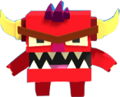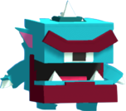



Player Characters

# A picture containing cake, sitting Description automatically generatedA B

Player Metrics

Cannon A: Simple cannon that attacks on Enemy at a time

Damage: 1

Reload: 1.2

Cost: $10

Cannon B: Dual cannon improved with improved fire rate

Damage: 1

Reload: 0.6

Cost: $17

Player States

**Idle**: The Player is idle when it isn’t firing at Goblins

**Move**: The Player moves/fires its cannons when an Enemy gets too close to it

**Death**: The Player dies when it receives significant damage to its health

# NPC

The Enemies spawn from different spawn points located in the environment (see Level Design). They are constantly searching for the Player. When they get close to the Cannon, they attack, producing different amounts of damage, depending on their type.

ENEMIES:

GOBLIN

SPEED MAX HEALTH SCORE VALUE ATTACK DAMAGE

2 1 1 10

BOXIMON FIERY

SPEED MAX HEALTH SCORE VALUE ATTACK DAMAGE

2 1 1 10

BOXIMON CYCLOPES

SPEED MAX HEALTH SCORE VALUE ATTACK DAMAGE

2 1 1 10

### Enemy States

**Idle**: The Enemies play the Idle state, only when the Player is dead, while seeing the losing screen, and before restarting the level.

**Move**: While the Player is alive, all enemies will be in the Move state, heading in the direction of the Player or Ally.

**Death**: Death happens when the Enemy sustains too much damage from an attack.

Art

# A drawing of a cartoon character Description automatically generatedrepresents when you can place towers

# displays the Players health

# starts the game

UNITY ASSETS

Forest - Low Poly Toon Battle Arena / Tower Defense Pack by AurynSky -> https://assetstore.unity.com/packages/3d/environments/forest-low-poly-toon-battle-arena-tower-defense-pack-100080

Winter Forest - Low Poly Toon Battle Arena / Tower Defense Pack by AurynSky -> https://assetstore.unity.com/packages/3d/environments/winter-forest-low-poly-toon-battle-arena-tower-defense-pack-150432

Goblin and Cannon by VSQUAD -> https://assetstore.unity.com/packages/3d/environments/fantasy/goblin-cannon-145437

SimpleSky by Synty Studios -> https://assetstore.unity.com/packages/3d/simple-sky-cartoon-assets-42373

Audio

"Menu Selection Click" by NenadSimic -> https://freesound.org/people/NenadSimic/sounds/171697/

"Air Horn" by Mike Koenig -> https://soundbible.com/1542-Air-Horn.html

"Bounce Sound" by Mike Koenig -> http://soundbible.com/1120-Bounce.html

"Determination" by artisticdude -> https://opengameart.org/content/determination

"Jab" by Mike Koenig -> http://soundbible.com/995-Jab.html

"No Hope" by CleytonKauffman -> https://opengameart.org/content/game-over-theme

"Lightstream" by Siddhartha -> https://freemusicarchive.org/music/Siddhartha/2019072480724742/Siddhartha_-_Constellations_-_05_Lightstream

"Tank Firing" by snottyboy -> https://soundbible.com/1326-Tank-Firing.html

# Setting

There are two different themes in this game that a Player can choose from, Forest Pack and Winter Arena and in each theme there are different levels, Easy, Medium, and Advanced, that a Player can experience.

# Level Design

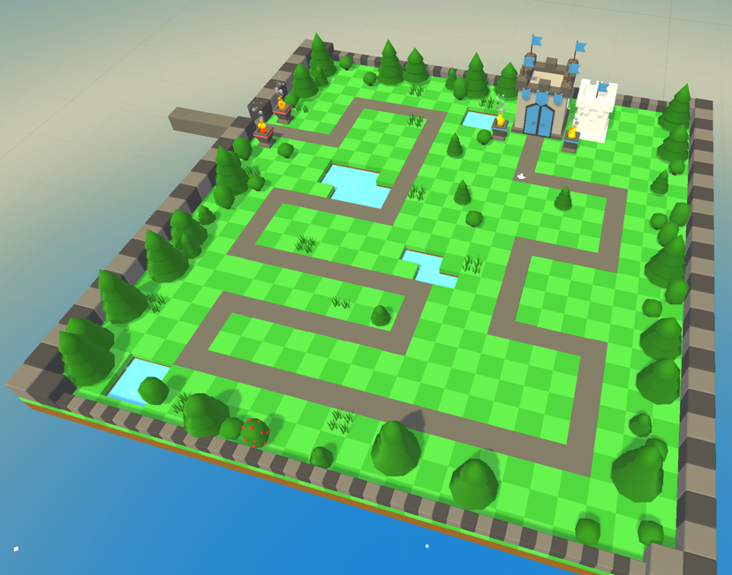



The levels are designed in to increase in difficulty as the Player advances through the game. In Figure above, the Goblins spawn from point A and point B represents the path in which they follow. The Player may place his/her tower anywhere on the green tiles, but not on the grey pathway.

## Minimum Viable Product (MPV)

Can only place one tower at a time

Built for the PC Platform

Wish List

* Instead of a cannon, in the future we could make maybe one character or multiple ones to choose from that fight the Goblins
* More Enemy variants as well
* More detailed artwork and information screens
* More dynamic storyline